SWE201C
1.
Requirement characteristics
- Reliability:
+ Understanding the requirements is difficult and unclear due to the limited information provided about constructive learning. (đề nói khá mơ hồ về khái niệm constructive learning, khai thác vào điểm này)
+ These requirements are still not sufficient to implement a complete application.
=> The reliability of these requirements from MEDIUM.
- Types and number of requirements
+ Requirements mention both functional requirements and non-functional requirements.
+ The total number of functional requirements could surpass 60, considering the presence of three distinct roles within the system, each potentially having more than 20 functional requirements. (đề có 3 roles, mỗi roles có 20+ func. Requirements, lợi dụng điểm này để mô tả rằng dự án phức tạp.)
- Frequency of requests may change (Những cái yêu cầu có thể thay đổi. Trong quá trình code, những yêu cầu có thể thay đổi. Anh đang code chức năng X mà sếp anh dở chúng muốn anh sửa X => Y.)
+ For a new development system, most project requirements depend largely on user needs and feedback. Therefore, requirements often change to meet them
+ When utilising the application, you obtain negative feedback from the lecturer or student as well as ideas for product development, so it must be updated or altered.
+ “FU has not had a similar system before, so there are many changes during development process” (Chết người đề cho mà không ghi vào, trừ điểm)
+ The team with a new development system often has a lot of creativity and constant innovation in the process of operating and implementing projects, so requirements can also change.
+ Because the project is employed in a continually changing environment (“number of students enrolling has increased very rapidly”), regular adjustments and upgrades are required to adapt swiftly. Requirements can be added, eliminated, or altered while the project is being implemented.
The requirements are subject to change on a regular basis. (Phần này làm kĩ vì đề khai thác sâu vào phần này.)
- Determination of requirements at an early stage
+ There are 3 primary criteria at first, but these can be updated in greater detail during the development process, and other requirements can be added to complete them.
+ Based on the requirements listed above, it is clear that the system has a few non-functional requirements to assure the product's quality, performance, and usability. As a result, non-functional things should be added.
=> The primary requirements have been established, but more should be added. (Tự dùng văn mình)
a. Development team
- Team size:
+ The project includes: “IT department and the development team participating in the project will include 4-6 extensive experience and skills develops”
+ The system is for students, lectures and academic staffs
=> As a result, this project is of medium size and the team size is medium.
- Experience of the developers:
+ “With the experienced resources of the FU’s IT department…include 4-6 extensive experience and skills developer” (Ghi câu nào vào ám chỉ là trình độ của dev là có KINH NGHIỆM => Scrum càng sướng)
=> The developers have goods knowledge to handle a complex system and structure (Suy luận từ câu trên)
- Level of understanding of user requirements by the developers: (trình độ am hiểu các yêu cầu của developers)
+ The requirements are clear enough for the team to grasp and implement. (tự chế => dev hiểu yêu cầu thì mới làm dễ được)
+ The team may have implement some system about education and have mục experience before so developer can easy understand requirement (tự chế)
+ When necessary, other departments can supply extra resources and information. (Tự chế)
=> As a result, Developers may readily comprehend what customers require. (Những thằng dev của anh nó hiểu dc requmrenets => tăng sự uy tín cho SCRUM)
b. User involvement in the project (số lượng người liên quan tới dự án)
- “Other departments commit to sending employees to join the project team to support project completion with high quality” (Những phòng ban khác có thể gửi NHÂN VIỆN (user) liên quan tới dự án. => SCRUM thì số lượng USER liên quan phải nhiều => câu này là 1 câu quá chuẩn để SCRUM => từ đề mà ra.)
- During development, the team will be given more resources. The university will contact the other department for employee support and additional information.
- This project is related to education so the involvement of education persons with understanding of this major are needed to contribute and assist the initiative.
- The university wants to develop new, groundbreaking products and rely heavily on user feedback, so user participation is extremely important to improve the project.
=> As a result, The project involves regular user participation to provide resources. (dự án nó liên quan quá NHIỀU NGƯỜI thì tao xài SCRUM là chuẩn chỉ)
c. Time constraints (ràng buộc thời gian làm dự án) and manager's expectation (trong mong của quản lý)
“FU leadership expects the first version of the system to be put into use within 3 months and the project needs to be completely completed within 9 months.” (tư đề, 1 dự án mà dài hơn 2 tháng dc xem là dự án vừa, > 6 tháng dự án lớn. Những dự án mà nó kéo dài vừa hoặc lớn => SCRUM ) => a medium project.
- The project requires the first version with main functions to be operational within 3 months and completed within 9 months, the team needs to come up with usable products first and then gradually develop and perfect. The agile model will meet the above requirements because it works in small, iterative stages and develops continuously, so it can release many product versions early.
Conclusion:
According to the characteristics outlined in the context of the software development project, the Agile/Scrum methodology is the most successful technique to implement. Throughout the project development process, Agile is adaptive to changing customer needs.Customers can often participate in the development process, assisting in the definition of their needs and wants. Furthermore, Agile projects are divided into sprints to assist control progress, generate workable versions, decrease risk and allow for project adjustments based on continuous client feedback. After all, the Agile/Scrum approach fits the above context perfectly and is capable of producing a successful, high-quality final product.

Question 2:
In the above case, there is the participation of IT deparment and the development team, and each person will have their own types of tests appropriate to each role and stage in the project. Developers mainly focus on using white box testing when implement and tester can use black box testing when tesing.
- Developer focus on using white box when implement :
+ Developers have deep knowledge of the source code, API, framework and also the code logic when deployed, they can easily detect weaknesses in the source code and optimize the code for testing.
+ The project requirement evaluating, voting, …so developer may user algorithms, logical structuer .White box testing allows developer to manipulate the program's source code and logical structure. This makes mistake detection in computational logic and algorithms more efficient and accurate. (thể hiện có hiểu)
+ White box testing assists developers in ensuring quality early in the implementation process, reducing the frequency of errors at the code level and other concerns.
- Tester focus on using black box testing when testing and before release different version:
+ Functional Testing: Tester frequently does black box testing to confirm that the system runs in accordance with the established functional requirements.
+ System Testing: Tester tests the entire system from the perspective of the end user to verify complete compatibility and performance.
+ Black box testing focuses primarily on functionality and user interface, allowing for quick and effective responses to user demands. Furthermore, when using this strategy, the analyst does not need to be know to much with the code, framework, API, and so on we can communication between users and development teams while also creating an unbiased and objective assessment of product features and quality.
+ The project require first version put into use with 3 month so use black box also help the team save time
Văn mẫu tự soạn ở nhà. Em chọn cả loại black() và whitebox (unit test, intergration tét,.. ), block dùng gì
Question 3: (1 func thì như 1 cái servlet)
- The 4 functional requirements of system are:
+ The lecturer can participate in reviews and ratings of exercise of student
+ The lecturer devide group student to assign presentation, assign questions,..
+ The lecturer can export list student from FAP, excel, ect to FU-EduNext
+ The student answer, edit, view my question and comment, vote answer of orther student
- The 2 non-functional requirements of system are: (đề này khác với đề trước, đề bài nó liệt kê luôn non functional)
+ User Authentication: The system should use secure and dependable user authentication mechanisms when student login by FU’s email on email platform.
Phải đảm bảo bảo mật khi vì hệ thông cho phép login bằng email.
+ Performance and reliability: When large user enroll FU-EduNext at the same time, the system must be able to work with require little respone time to ensure performance and reliabilit
Question 6:
As a student, I want to view and vote anwser of other sutdent on my group so that I can compare and check to find the correct answer.
As a student, I want to login FU-EduNext by FU’s email account so that I can save time and don’t need to fill user and password

Question 4:
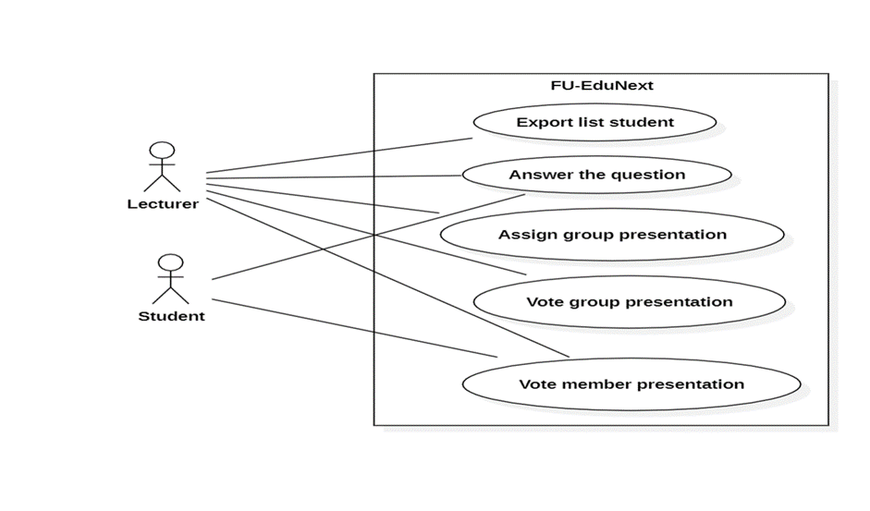
Question 5:
Test Case 1: Login with account email (clear, test suite => coverage, bao quat)
(chi tiết , 1 test case cho 1 usecase => chi tiết)
Desciption: Ensure that user can you FU’s email account to login
Steps:
a.Choose option login with email
b.Move to gmail platform
c.Check and confirm that account valid
Expected Result: User can login successful with account email and move to home web

Test Case 2: Posting and Editing Answer
Description: Ensure that student or lecturer can post answer and edit their posts as needed.
Steps:
a. Log in to the FU-EduNext.
b. Write a new answer with text, images, or multimedia content.
c. Verify that the answer appears in the communicate's about answer page.
d. Edit the answer and confirm that changes are reflected.
Expected Result: Users should be able to create comment about answer with various content types and edit their posts without issues.
Test Case 3: Convert file excel to get list student
Description: Confirm that lecturer can use file and upload, convert file in to web.
Steps:
a. Add a file to create new group student.
b. Confirm that the file is available and attached.
c. Convert and verify the integrity of the attached file.
Expected Result: File convert should work smoothly, with files being uploaded, accessible and can get a group student
Test case 4: Vote rate of group presentation or assignment
Desciptiont: Ensure that lecturer can vote rate of presentation
a. Choose group student to vote
b. Confirm that presentation or assignment are finished
c.Vote student’s presentation or assignment (from 1 stars to 5 start)
Expected value: Lecturer can vote rate for student’group

Question7:

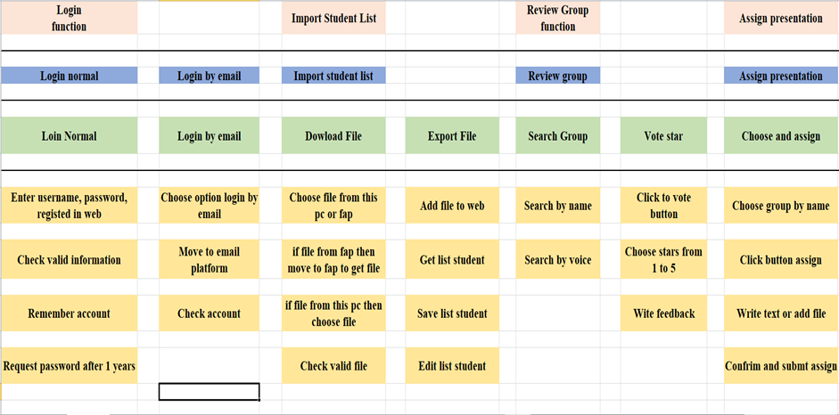

C

